TITLE OF MICRO PROJECT
COMPACT POSE-BASED ISL RECOGNITION
a micro project e-report Submitted by

DAVID MAMMEN (URK25CS7021)
POTTA VISWANI (URK25CS7034)
IYNESHA J (URK25CS7067)
ASHWIN S (URK25CS7068)

In partial fulfilment of the Continuous Internal Examination
of
25AI306 -Data Science
in
B. TECH COMPUTER SCIENCE AND ENGINEERING [ AIML/AI]
under the supervision of
Sindhu


KARUNYA INSTITUTE OF TECHNOLOGY AND SCIENCES
(Deemed-to-be-University)
Karunya Nagar, Coimbatore - 641 114.
October 2026

BONAFIDE CERTIFICATE

This is to certify that the micro project e-report titled “COMPACT POSE-BASED ISL RECOGNITION” is the bonafide work of “DAVID MAMMEN (URK25CS7021)
POTTA VISWANI (URK25CS7034),IYNESHA J (URK25CS7067),ASHWIN S (URK25CS7068)” who carried out the project work under my supervision.

COURSE FACULTY
Name: Sindhu
Designation
Division of Artificial Intelligence and Machine Learning

Submitted for the micro project presentation held on 30.10.2026

ABSTRACT
Indian Sign Language (ISL) is an important communication medium for people who are deaf or hard of hearing. However, communication barriers can arise when others do not understand sign language. A computer-based recognition system can help reduce this gap by identifying supported signs and presenting them as text or speech. This micro-project, “Compact Pose-Based Word-Level Indian Sign Language Recognition,” explores isolated-sign recognition using pose sequences, machine learning, and deep learning.

The approach uses pose data derived from the INCLUDE Indian Sign Language benchmark through the OpenHands resource. Rather than processing raw videos throughout training, it represents body and hand movements as numerical landmark coordinates. This representation can reduce storage needs and make experimentation more practical on student-level computers. MediaPipe is considered for extracting landmarks from webcam frames, provided that the live input matches the model’s training format.

Six candidate models are compared: Support Vector Machine (SVM), Random Forest, Long Short-Term Memory (LSTM), Gated Recurrent Unit (GRU), one-dimensional Convolutional Neural Network (1D-CNN), and a compact Transformer. The supplied benchmark evaluates these models on a five-class greeting subset containing 106 video clips and 16 held-out test samples. Reported test accuracies are 68.8% for SVM, 87.5% for Random Forest, 62.5% for Bi-LSTM, 87.5% for Bi-GRU, 87.5% for 1D-CNN, and 81.2% for the compact Transformer. The 1D-CNN records the highest macro-F1 score, 0.883, and a reported inference latency of 1.02 milliseconds.

These results suggest that compact pose-based recognition is promising, but the small test set limits the conclusions that can be drawn. The project focuses on isolated-word recognition, not continuous conversation or complete sign-language translation. Future work should expand the dataset, test performance on unseen signers, and validate the complete webcam-to-text-and-speech pipeline.
Keywords: Indian Sign Language, pose estimation, MediaPipe, machine learning, deep learning, 1D-CNN, sign recognition, assistive technology.
TABLE OF CONTENTS

S.No. | Title |  | Page No.
 | BONAFIDE CERTIFICATE |  | ii
 | ABSTRACT |  | iii
 | TABLE OF CONTENTS |  | iv
1 | INTRODUCTION |  | 5
 | 1.1 | Background of the selected problem | 5
 | 1.2 | Industry Relevance | 6
 | 1.3 | Aim and Objective of the Micro Project | 2
 | 1.4 | Link to SDG / KITS Technology Mission | 2
2 | LITERATURE REVIEW |  | 7
3 | METHODOLOGY |  | 8
4 | FABRICATION/SIMULATION/PROGRAM OR CODE/DESIGN |  | 9
5 | RESULTS AND INTERPRETATION |  | 12
6 | CONCLUSION AND FUTURE SCOPE |  | 15
7 | DECLARATION |  | 16

- INTRODUCTION
1.1Background of the Selected Problem
Indian Sign Language (ISL) plays an important role in helping people who are deaf or hard of hearing communicate with others. However, communication can become difficult when people around them do not understand sign language. This creates challenges in education, healthcare, public services, and everyday activities. Therefore, developing an automatic sign language recognition system can help reduce communication barriers and support inclusive communication.

This project uses Artificial Intelligence (AI), machine learning, and pose estimation to recognize isolated Indian Sign Language words. The system uses numerical body and hand landmarks derived from the INCLUDE benchmark through OpenHands. These landmarks represent body and hand movements as numerical coordinates, making it easier for machine learning models to analyze sign patterns without directly processing the entire video.

The project compares six machine learning models: Support Vector Machine (SVM), Random Forest, Long Short-Term Memory (LSTM), Gated Recurrent Unit (GRU), One-Dimensional Convolutional Neural Network (1D-CNN), and Transformer. Each model is studied to understand its ability to recognize signs based on accuracy and processing speed. The main objective is to identify a suitable and efficient model that can support the future development of an ISL recognition system with text or speech output.

1.2 Industry Relevance
The proposed system has potential applications in:
- Education: Supporting communication between students and teachers.
- Healthcare: Helping with basic communication in hospitals.
- Public services: Improving accessibility at service centres.
- Workplaces: Supporting communication between employees.
The system could improve accessibility, but further testing is required before practical deployment.

1.3 Aim and Objectives of the Micro-Project
Aim: To develop and evaluate a compact pose-based system for recognizing isolated Indian Sign Language words.

Objectives:
- Study existing ISL recognition research.
- Prepare and process pose landmark data.
- Compare six machine learning and deep learning models.
- Evaluate accuracy, macro-F1, and inference latency.
- Identify a suitable model for further development.
- Explore webcam-based recognition with text and speech output.

1.4 Link to SDG / KITS Technology Mission
SDG 4 – Quality Education: Supports inclusive learning and communication.
SDG 9 – Industry, Innovation and Infrastructure: Applies AI and computer vision to assistive technology.
SDG 10 – Reduced Inequalities: Aims to reduce communication barriers for people who use sign language.
KITS Technology Mission: The project applies data science and AI concepts to a real-world accessibility problem through data preprocessing, model development, and performance evaluation.

2. LITERATURE REVIEW
- Existing Research
1.INCLUDE – Sridhar et al. (2020Introduced a large-scale Indian Sign Language (ISL) dataset. It provides a foundation for training and evaluating sign recognition models.
2.OpenHands – Selvaraj et al. (2022)
Introduced standardized pose-based data for sign recognition. It supports using body and hand landmarks instead of processing raw videos.
3. MediaPipe and LSTM – Khartheesvar et al. (2024)
Combined MediaPipe landmarks with LSTM to recognize ISL signs. This supports using landmarks and sequential models for sign recognition.
4. Transformer-Based Recognition – Patra et al. (2025)
Explored Transformer-based methods for ISL recognition, showing the potential of attention-based models.
5. SPOTER – Boháček and Hrúz (2022)
Used pose-based Transformer architecture for word-level sign recognition, providing a reference for sequence modelling.
6. AUTSL and WLASL Datasets
These studies highlight the importance of dataset quality, word-level recognition, and testing models on unseen signers.
- Research Gap
Existing studies use different datasets, models, and evaluation methods. Their results cannot be directly compared. Therefore, this project compares six models—SVM, Random Forest, LSTM, GRU, 1D-CNN, and Transformer—using a common pose-based dataset. Accuracy, macro-F1 score, and inference latency are considered to identify a suitable compact model.
- Summary
The literature supports the use of pose landmarks and machine learning for sign language recognition. This project builds on previous research by comparing classical and deep learning models for isolated ISL word recognition. Further testing is required to evaluate performance on unseen signers and in live webcam conditions.

3. METHODOLOGY

- Algorithm
Input: A labelled dataset of isolated ISL pose sequences.
Output: A predicted sign class and evaluation metrics.
- Load the prepared pose dataset and its labels.
- Verify the class definitions, sequence dimensions, and available data splits.
- Inspect missing values, invalid landmarks, and duplicate samples.
- Normalize the landmark coordinates consistently.
- Prepare fixed-length sequences for sequential models.
- Generate fixed-dimensional feature vectors for SVM and Random Forest.
- Train each candidate model using the training data.
- Use validation data for model selection and parameter tuning.
- Evaluate the trained models on the held-out test set.
- Calculate accuracy, precision, recall, macro-F1, and confusion matrices.
- Measure inference latency under the documented benchmark conditions.
- Compare the results and select a candidate model for further testing.
- For live integration, extract landmarks from webcam frames and apply the same preprocessing.
- Generate the predicted sign label and provide text or speech output if the prototype integration is working.
- Methodology Summary
The methodology combines compact numerical pose representation with supervised classification. A controlled comparison of different model architectures provides a basis for selecting a model according to both recognition quality and computational performance. The supplied results identify 1D-CNN as a promising candidate, while the small test set and the distinction between offline evaluation and live use require further validation.

4. SIMULATION

- Simulation Overview
The project, “Compact Pose-Based Word-Level Indian Sign Language Recognition,” focuses on recognizing Indian Sign Language (ISL) words using pose landmarks and machine learning techniques. The simulation compares different models to identify a suitable model for accurate and efficient sign recognition.

- Dataset Preparation
A five-class ISL greeting subset is used for the experiment. The dataset contains 106 clips, with 16 samples reserved for testing. Pose landmark data is prepared and normalized before being given as input to the models. Sequential models use 32 frames with 138 coordinates, while classical models use 291-dimensional features.

- Model Simulation
Six machine learning models are evaluated:
- SVM: Classifies signs using learned decision boundaries.
- Random Forest: Combines multiple decision trees to predict sign classes.
- LSTM: Learns patterns across sequences of landmark data.
- GRU: Processes sequential movement information using a compact recurrent structure.
- 1D-CNN: Extracts useful patterns from landmark sequences using convolution.
- Transformer: Uses attention mechanisms to learn relationships between sequence elements.
- 4.4 Model Comparison
- This heading suits your project because you are comparing six machine learning models based on accuracy and inference latency.

Simulation Results
The results show that Random Forest, Bi-GRU, and 1D-CNN achieved the highest reported accuracy of 87.5%. Among these models, 1D-CNN had a lower reported inference latency of 1.02 ms than Random Forest and Bi-GRU. Therefore, 1D-CNN is a promising choice for further development.

Conclusion
The simulation demonstrates how different machine learning models can be compared for ISL word recognition using pose landmark data. The results help identify a model that balances accuracy and processing speed. However, the test set is small, so the results are preliminary. Testing with more samples and unseen signers is needed. Live webcam recognition and speech output also require separate implementation and evaluation.

5. RESULTS AND INTERPRETATION

- Overall Interpretation
The supplied benchmark demonstrates that compact pose features can be used to compare several machine learning and deep learning approaches for isolated ISL recognition. Among the tested models, 1D-CNN provides the strongest macro-F1 score and low inference latency, making it a promising candidate for further development.

At the same time, the limited size of the evaluation set prevents strong conclusions about generalization. Further experiments should use more samples, verify signer identities, evaluate unseen-signer performance where possible, and measure the complete live pipeline. These steps are necessary before the system can be described as a reliable practical communication aid.

6.CONCLUSION AND FUTURE SCOPE
- Conclusion
The micro-project, Compact Pose-Based Word-Level Indian Sign Language Recognition, investigates the use of compact pose sequences for recognizing supported isolated Indian Sign Language words. The project is motivated by the communication barriers that can occur when ISL users interact with people who do not understand sign language.

The proposed approach uses numerical landmark representations derived from the INCLUDE benchmark through OpenHands. This approach can reduce dependence on raw video during model training and provides structured inputs for machine learning and deep learning algorithms.
Six candidate architectures were considered in the supplied benchmark: SVM, Random Forest, Bi-LSTM, Bi-GRU, 1D-CNN, and a compact Transformer. The benchmark report records a five-class greeting experiment containing 106 video clips and 16 held-out test samples.

Random Forest, Bi-GRU, and 1D-CNN achieved the highest reported accuracy of 87.5%. Among these, 1D-CNN obtained the highest macro-F1 score of 0.883 and a reported inference latency of 1.02 milliseconds. It was consequently selected as the champion architecture in the supplied benchmark report.

These results suggest that 1D-CNN is a promising candidate for further investigation because it combines good classification performance with relatively low inference latency and a comparatively small number of trainable parameters.

However, the results are preliminary. The small test set and limited vocabulary do not establish broad ISL recognition performance or reliable generalization to unseen signers. The benchmark's model inference times also do not establish the response time of a complete webcam-based application.

The project establishes an experimental foundation for further development of a pose-based ISL recognition system. Future work should prioritize larger-scale evaluation, signer-aware testing, and validation of the complete webcam-to-text-and-speech pipeline.
- Future Scope
The following improvements can be considered in future development.
1. Expand the dataset
The number of training and test samples should be increased, and more isolated ISL words should be included. This would help assess the model's performance across a wider vocabulary.

2. Improve signer diversity
Data should include multiple signers with different signing styles and recording conditions. Signer-disjoint evaluation should be performed where reliable signer metadata is available.

3. Validate live webcam integration
The complete pipeline should be tested using webcam input, MediaPipe landmark extraction, normalization, sequence buffering, and the selected classifier. The predicted word should be checked against the sign actually performed.

4. Integrate text and speech output
A working prototype should display the predicted sign label and generate corresponding speech. The system should be tested for incorrect predictions, empty inputs, and low-confidence cases.

5. Improve preprocessing
Further work can investigate missing-landmark handling, coordinate normalization, temporal resampling, and training-only augmentation to improve robustness.

6. Investigate model optimization
Quantization, pruning, and other appropriate optimization methods could be explored to reduce model size and improve inference efficiency.

7. Evaluate the complete system
End-to-end response time should be measured, including webcam capture, landmark extraction, model inference, and speech generation.

8. Expand to continuous sign recognition
A more advanced system could investigate continuous signing and sentence-level interpretation. This would require additional data, temporal segmentation, and methods that account for the linguistic structure of ISL.

9. Improve reliability and user feedback
The interface could include confidence thresholds, clear error messages, and a mechanism for users to repeat or correct a sign when recognition is uncertain.

10. Conduct usability testing
The system should be evaluated with appropriate participants and accessibility considerations before being used in practical communication settings.

- Final Statement
The project demonstrates the value of combining pose-based feature representation with comparative machine learning evaluation. The supplied benchmark identifies 1D-CNN as a promising model for the selected five-class experiment. Further data collection, signer-aware evaluation, and verified live integration are required to establish the reliability and practical usefulness of the system.

REFERENCES

1. Sridhar, A., et al. (2020). “INCLUDE: A Large Scale Dataset for Indian Sign Language Recognition.” Proceedings of the ACM International Conference on Multimedia. https://doi.org/10.1145/3394171.3413528
2. Selvaraj, P., et al. (2022). “OpenHands.” Proceedings of the Association for Computational Linguistics. OpenHands paper and dataset resources.
3. Khartheesvar, G., et al. (2024). “Automatic ISL Recognition Using MediaPipe Holistic and LSTM.” Multimedia Tools and Applications. https://doi.org/10.1007/s11042-023-17361-y
4. Patra, S., et al. (2025). “Hierarchical Windowed Graph Attention Transformer Encoder and a Large Scale Dataset for ISL Recognition.” Pattern Analysis and Applications. https://doi.org/10.1007/s10044-025-01529-3
5. Boháček, M., and Hrúz, M. (2022). “Sign Pose-Based Transformer (SPOTER).” Proceedings of the IEEE/CVF Winter Conference on Applications of Computer Vision Workshops. https://doi.org/10.1109/WACVW54805.2022.00024
6. Sincan, O. M., and Keles, H. Y. (2020). “AUTSL: A Large Scale Multi-Modal Turkish Sign Language Dataset and Benchmark.” IEEE Access. https://doi.org/10.1109/ACCESS.2020.3028072
7. Li, D., et al. (2020). “Word-Level Deep Sign Language Recognition from Video: A New Large-Scale Dataset and Methods Comparison.” Proceedings of the IEEE/CVF Winter Conference on Applications of Computer Vision. https://doi.org/10.1109/WACV45572.2020.9093512
8. Adaloglou, N., et al. (2022). “A Comprehensive Study of Deep Learning Methods for Sign Language Recognition.” IEEE Transactions on Multimedia. https://doi.org/10.1109/TMM.2021.3070438

DECLARATION

I understand that Karunya Institute of Technology and Sciences retains the rights to any product developed (software or hardware) through the Micro Project submitted by me to the Institution.

Furthermore, if I intend to document or publish any findings from the Micro Project work for commercial purposes, I shall obtain a No Objection Certificate (NOC) from the Office of the Registrar before engaging in such activities.

I also understand that any patentable outcomes arising from the Micro Project shall be reported to the Institution, and that patent filing, ownership, and revenue-sharing will be governed by the Intellectual Property Rights (IPR) policies of Karunya Institute of Technology and Sciences.
I acknowledge that any commercial utilization or republication of the Micro Project work, in full or in part, shall require prior permission from Karunya Institute of Technology and Sciences. I further agree that any royalty accruing from such utilization will be shared between the inventor(s) and the Institution in the ratio of 60:40, respectively, in accordance with the Institute’s Intellectual Property Rights policy.

Signature of the Student: | 
Name of the Student: | DAVID MAMMEN
Register Number: | URK25CS7021
Date: | 30.10.2026

Signature of the Student: | 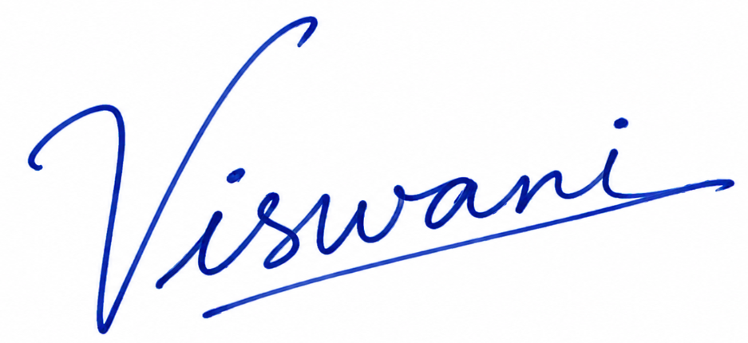
Name of the Student: | POTTA VISWANI
Register Number: | URK25CS7034
Date: | 30.10.2026

Signature of the Student: | 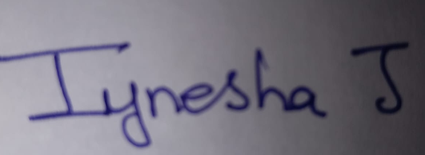
Name of the Student: | IYNESHA J
Register Number: | URK25CS7067
Date: | 30.10.2026

Signature of the Student: | 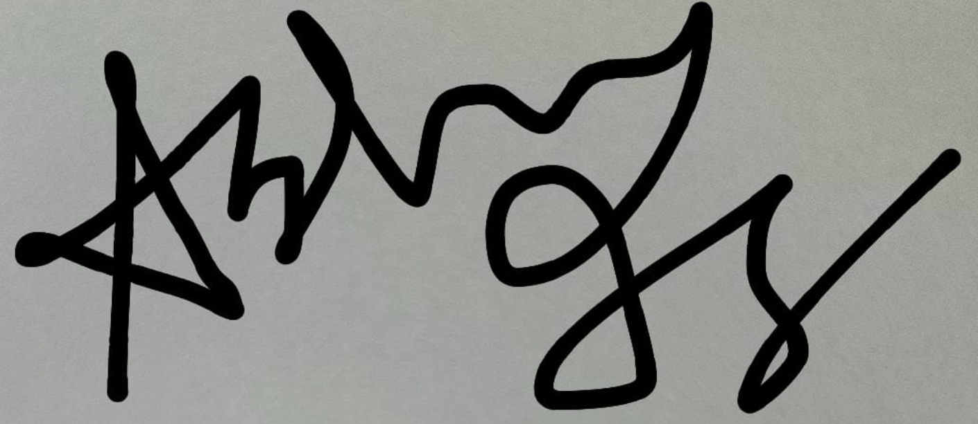
Name of the Student: | ASHWIN S
Register Number: | URK25CS7068
Date: | 30.10.2026

